Real Road Adventures with Jeff Wilson
Real Road Adventures host Jeff Wilson pauses while mountain biking at the base of the iconic Matterhorn in Switzerland. In the car-free regions of the Matterhorn and Schilthorn, Jeff travels by electrically powered cable cars, trains, and bikes for heart-stopping mountain views. He savors the splendor of the Lauterbrunnen Valley, a wonderland of 72 waterfalls. He maneuvers over sheer mountain walls on a fixed climbing route called a “Via Ferrata,” and indulges in a luxury eco-resort.

Real Road Adventures highlights include: the “E-Grand Tour of Switzerland”; the UNESCO Biosphere in the Entlebruch Valley; medieval castles in Liechtenstein and Avanches; white-water rafting near Interlaken; e-biking in in Zurich, the vineyards of Lavaux and on the Liechtenstein Trail; spectacular Staubbach Falls in the Lauterbrunnen Valley; and hiking with llamas in Liechtenstein and black-nose sheep above Zermatt. Major corporate support provided by Volkswagen America.

Real Road Adventures with Jeff Wilson, a six-part series on sustainable travel, is produced by Small World Productions, co-produced by Cascade Public Media / KCTS Seattle, and distributed nationally by American Public Television Exchange.

Jeff Wilson, host of Real Road Adventures, explores the organic vineyards of Lavaux above Lake Geneva on an e-bike. In episode 105 Jeff takes on the Lake Geneva region of Switzerland a hub of visionary world leaders and scenic splendor. He marvels at Roman ruins, surveys a butterfly sanctuary, and samples ice cream made from sheep’s milk. Efforts to solve global challenges are all around and Jeff learns about cutting-edge technology, including a “garbage truck” in space and the inventive “Youth for Soap” recycling program. Jeff rounds out his visit to the region relishing the sunset aboard a gourmet dinner cruise on spectacular Lake Geneva.

Real Road Adventures highlights include: the “E-Grand Tour of Switzerland”; the UNESCO Biosphere in the Entlebruch Valley; medieval castles in Liechtenstein and Avanches; white-water rafting near Interlaken; e-biking in in Zurich , the vineyards of Lavaux and on the Liechtenstein Trail; spectacular Staubbach Falls in the Lauterbrunnen Valley; and hiking with llamas in Liechtenstein and black-nose sheep above Zermatt. Major corporate support provided by Volkswagen America.

Real Road Adventures with Jeff Wilson, a six-part series on sustainable travel, is produced by Small World Productions, co-produced by Cascade Public Media / KCTS Seattle, and distributed nationally by American Public Television Exchange.

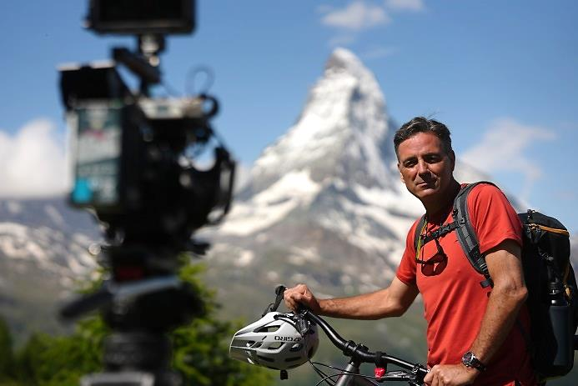

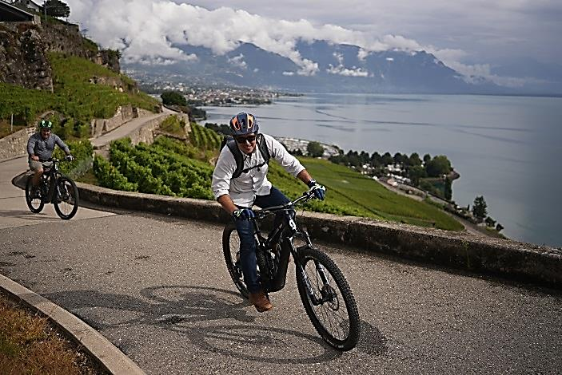

Real Road Adventures with Jeff Wilson
Real Road Adventures host Jeff Wilson readies for the “E-Grand tour of Switzerland” as he picks up a battery-powered electric car at Zurich Airport. In this all new six-part series Jeff discovers the freedom, safety, and convenience of European travel via electric car. He marvels at how Switzerland and Liechtenstein are conserving their natural beauty and fragile ecosystems. He plunges into the great outdoors for intoxicating, eco-friendly sports: kayaking, e-biking, white-water rafting and more. Jeff checks out environmentally friendly accommodations – from rustic country inns to award-winning luxury hotels with sustainable practices. And he seeks out opportunities for retreat and self-discovery, as he takes the road less traveled, visiting hidden villages and befriending locals who have discovered the secrets to work-life balance.

Real Road Adventures with Jeff Wilson, a six-part series on sustainable travel, is produced by Small World Productions, co-produced by Cascade Public Media / KCTS Seattle, and distributed nationally by American Public Television Exchange. Major corporate support provided by Volkswagen America.

In Real Road Adventure, a new six-part series from American Public Television, host Jeff Wilson cruises through the most breathtaking landscapes on Earth - from jagged, snow-white Alps to the rolling countryside of the Entlebuch Valley. Things get supercharged when he hops off the road for more electric adventures: e-bike tours, exhilarating rides on solar-powered cable cars, and lake cruises on eco-friendly ferries. Throughout the series, Jeff maximizes his travel fun, while at the same time reducing his environmental impact.

Real Road Adventures highlights include: the “E-Grand Tour of Switzerland”; the UNESCO biosphere in the Entlebruch Valley; medieval castles in Liechtenstein and Avanches; white-water rafting near Interlaken; e-biking in in Zurich and the vineyards of Lavaux; spectacular Staubbach Falls in the Lauterbrunnen Valley; and hiking with llamas in Liechtenstein and black-nose sheep above Zermatt.

Real Road Adventures with Jeff Wilson is produced by Small World Productions, co-produced by Cascade Public Media / KCTS Seattle, and distributed nationally by American Public Television Exchange. Major corporate support provided by Volkswagen America.

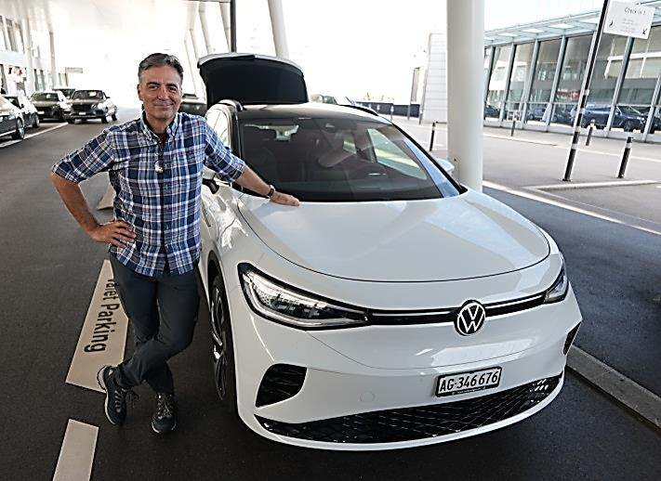

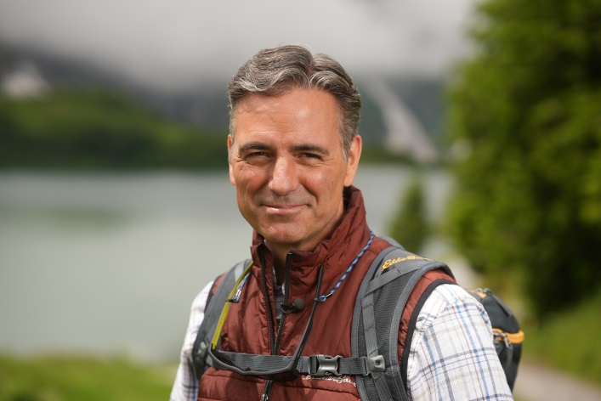
Real Road Adventures with Jeff Wilson

Real Road Adventures host Jeff Wilson strolls the streets of Zermatt Switzerland at the base of the Matterhorn. In the car-free regions of the Matterhorn and Schilthorn, episode 103, Jeff travels by electrically powered cable cars, trains, and bikes for heart-stopping mountain views. He savors the splendor of the Lauterbrunnen Valley, a wonderland of 72 waterfalls. He maneuvers over sheer mountain walls on a fixed climbing route called a “Via Ferrata,” and indulges in a luxury eco-resort.

Real Road Adventures highlights include: the “E-Grand Tour of Switzerland”; the UNESCO Biosphere in the Entlebruch Valley; medieval castles in Liechtenstein and Avanches; white-water rafting near Interlaken; e-biking in in Zurich, the vineyards of Lavaux and on the Liechtenstein Trail; spectacular Staubbach Falls in the Lauterbrunnen Valley; and hiking with llamas in Liechtenstein and black-nose sheep above Zermatt.

Real Road Adventures with Jeff Wilson, a six-part series on sustainable travel, is produced by Small World Productions, co-produced by Cascade Public Media / KCTS Seattle, and distributed nationally by American Public Television Exchange. Major corporate support provided by Volkswagen America.
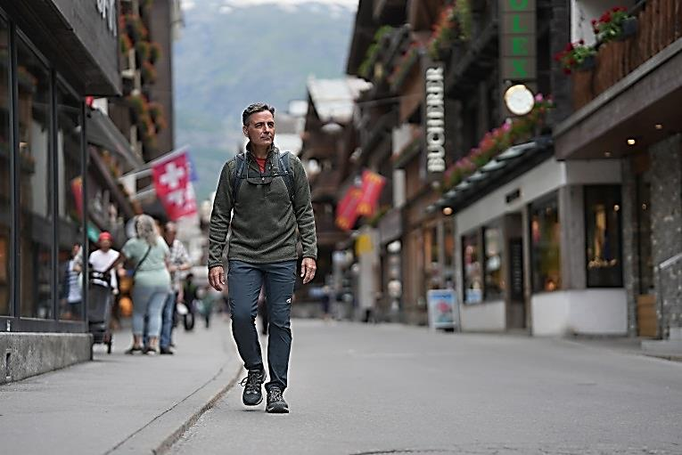

Real Road Adventures host Jeff Wilson explores “a giant in the world of sustainable destinations,” Central Switzerland’s Entlebuch Biosphere Reserve. Part of the UNESCO Biosphere Program, the Entlebuch Biosphere is a 150 square mile area that works to improve the relationship between people and their environments. Switzerland is primed for high-voltage, low impact summer fun. Jeff hikes high into the pristine Alps, bicycles around a breathtaking mountain lake, goes panning for gold in a gorgeous gorge, and relaxes in a spa-like nature preserve. He strolls the colorful murals of Lucerne’s beautiful old town and glides its azure lake in the country’s first climate-neutral cruise ship. In the bucolic farmland of Entlebuch, Jeff follows the clues on the Marbach food trail, sampling organic local specialties at every stop.

Real Road Adventures with Jeff Wilson, a six-part series on sustainable travel, is produced by Small World Productions, co-produced by Cascade Public Media / KCTS Seattle, and distributed nationally by American Public Television Exchange. Major corporate support provided by Volkswagen America.

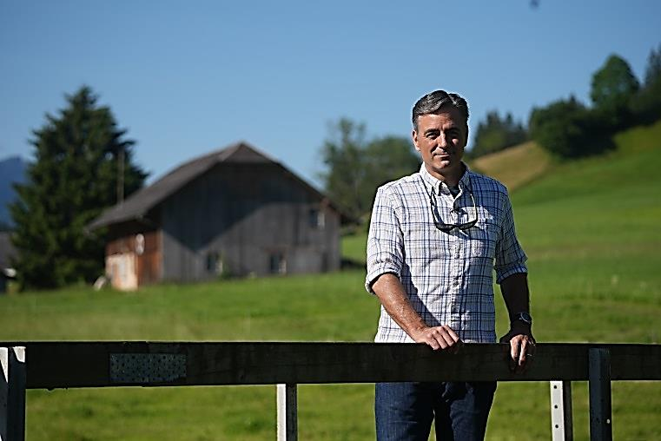

Real Road Adventures with Jeff Wilson

In Real Road Adventures, a new six-part series on sustainable travel from American public television, host Jeff Wilson follows the “E-Grand Tour of Switzerland” in a battery powered electric car and revels in the scenic wonders, multicultural heritage, and world-class tourism resources of Switzerland and Liechtenstein. Throughout the series Jeff promotes thoughtful, responsible travel and good global citizenship.

Real Road Adventures highlights include: the “E-Grand Tour of Switzerland”; the UNESCO biosphere in the Entlebruch Valley; medieval castles in Liechtenstein and Avanches; white-water rafting near Interlaken; e-biking in Zurich the vineyards of Lavaux and the Liechtenstein Trail; spectacular Staubbach Falls in the Lauterbrunnen Valley; and hiking with llamas in Liechtenstein and black-nose sheep above Zermatt.

Real Road Adventures with Jeff Wilson is produced by Small World Productions, co-produced by Cascade Public Media / KCTS Seattle, and distributed nationally by American Public Television Exchange. Major corporate support provided by Volkswagen America.
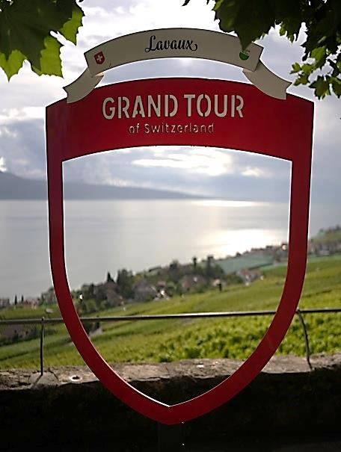

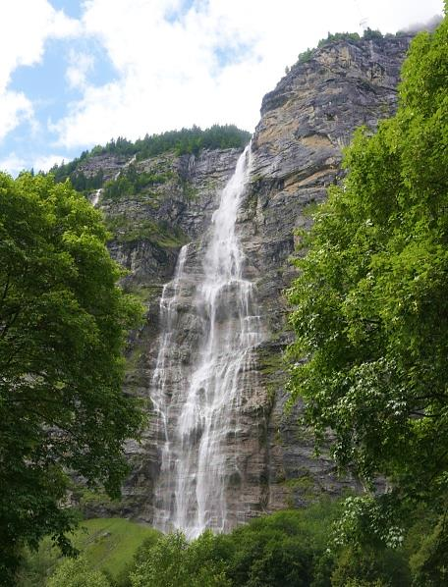
Spectacular Staubbach Falls in the Lauterbrunnen Valley is just one of the scenic splendors featured in Real Road Adventures a new six-part series on sustainable travel from American Public Television. In a battery powered car, host Jeff Wilson tracks the “E-Grand Tour of Switzerland” and discovers the freedom, safety, and convenience of European travel by EV. All along the way, Jeff marvels at how Switzerland and Liechtenstein are conserving their natural beauty and fragile ecosystems. He plunges into the great outdoors to discover intoxicating, eco-friendly sports: kayaking, e-biking, white-water rafting and more. Jeff checks out environmentally friendly accommodations – from rustic country inns to award-winning luxury hotels with sustainable practices. And he seeks out opportunities for retreat and self-discovery, on the road less traveled, visiting hidden villages and befriending locals who have discovered the secrets to work-life balance.

Real Road Adventures with Jeff Wilson is produced by Small World Productions, co-produced by Cascade Public Media / KCTS Seattle, and distributed nationally by American Public Television Exchange. Major corporate support provided by Volkswagen America.

