Real Road Adventures
Program Descriptions--Real Road Adventures with Jeff Wilson
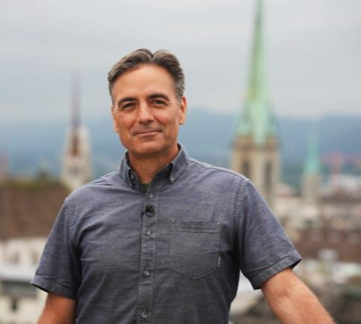
101 – Zurich
The road to exciting trends leads directly to Zurich. There’s innovation around every corner as Jeff takes an e-bike tour through Zurich’s urban art scene, feasts on ultra-fresh vegan food at a Michelin-starred restaurant, and visits a forward-thinking company that collects discarded plastic bottles and transforms them into clothing. He rows across shimmering Lake Zurich, visits the mouthwatering “Home of Chocolate,” and learns about revolutionary technology that prevents food waste. Finally, Jeff makes a side-trip to a stunning, centuries-old Benedictine abbey that’s Switzerland’s most important pilgrimage site.

102 – Lucerne – Lake Lucerne Region
Charge up your electric car, your e-bike and your appetite - Lucerne and Central Switzerland are primed for high-voltage, low impact summer fun. Jeff hikes high into the pristine Alps, bicycles around a breathtaking mountain lake, goes panning for gold in a gorgeous gorge, and relaxes in a spa-like nature preserve. He strolls the colorful murals of Lucerne’s beautiful old town and glides its azure lake in the country’s first climate-neutral cruise ship. In the bucolic farmland of Entlebuch, Jeff follows the clues on the Marbach food trail, sampling organic local specialties at every stop.
103 – Schilthorn and Zermatt - Matterhorn
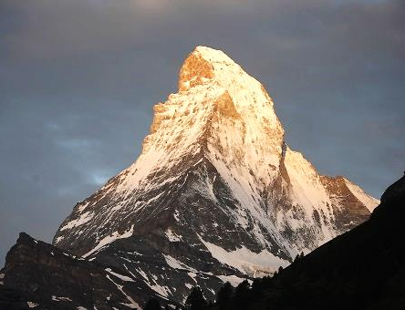
Electric cars are fantastic for getting you where you need to go, but there are a few Alpine regions that are so special, they’re worth parking the car and just plunging in. In the car-free regions of the Schilthorn and Matterhorn, Jeff travels by electrically powered cable cars, trains, and bikes for heart-stopping mountain views. He savors the splendor of the Lauterbrunnen Valley, a wonderland of 72 waterfalls. He maneuvers over sheer mountain walls on a fixed climbing route called a “Via Ferrata,” and indulges in a luxury eco-resort. Hiking in the shadow of the Matterhorn, Jeff cavorts with adorable blacknose sheep.

104 – Interlaken and Jungfrau Region
Adventure is full speed ahead in Switzerland’s Jungfrau region. Jeff sails over the Alps on specialized ziplines and soars 11,000 feet above sea level to the “Top of Europe” at the Junfraujoch. He wanders the medieval ramparts of a fairytale castle, gets a crash course in making his own organic chocolate, and discovers how a traditional alphorn is crafted. In crystal mountain waters, Jeff focuses on sports that leave a light environmental footprint, from thrilling white water rafting to soul-soothing kayaking.
Major corporate support for Real Road Adventures is provided by Volkswagen America.

| Produced by Small World Productions | 4810 South Oregon Street | Seattle, 98118
| 206.329.7167 | contact: JohnGivens@TravelSmallWorld.com | web site: www.RealRoadTV.com
| Co-produced by KCTS/Seattle | Distributed nationally by American Public Television Exchange
| Copyright ©2022 by Small World Productions, Inc.
Real Road Adventures
105 – Lake Geneva Region
Shifting into cultural high gear, Jeff takes on the Lake Geneva region, hub of visionary world leaders and scenic splendor. He marvels at Roman ruins, surveys a butterfly sanctuary, rides an e-bike through organic vineyards, and samples ice cream made from sheep’s milk. Efforts to solve global challenges are all around and Jeff learns about cutting-edge technology, including a “garbage truck” in space and the inventive “Youth for Soap” recycling program. Jeff rounds out his visit relishing the sunset aboard a gourmet dinner cruise on spectacular Lake Geneva.

106 – Liechtenstein
It’s a journey on the road less travelled when Jeff visits the tiny country of Liechtenstein. A scenic, prosperous “microstate,” Liechtenstein punches above its weight in sustainability and outdoor fun. Jeff explores the Liechtenstein Trail, a 46-mile path that winds through the entire country and highlights the best attractions. He’s joined by some unique hiking partners, including llamas, and alpacas. He delves into history with woodcarving that evokes ancient legends, and ponders the future at an innovative farm that considers “How will humans eat tomorrow?”

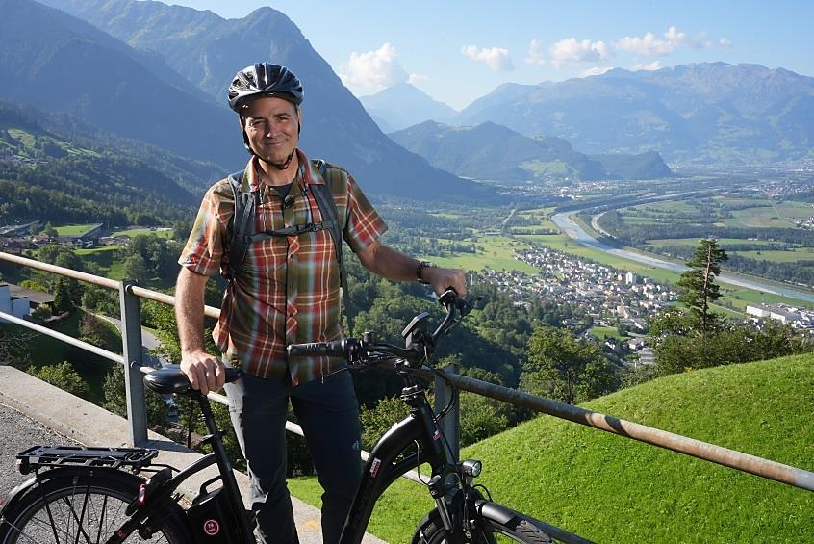

Major corporate support for Real Road Adventures is provided by Volkswagen

|Produced by Small World Productions | 4810 South Oregon Street | Seattle, 98118|
| 206.329.7167 | contact: JohnGivens@TravelSmallWorld.com | web site: www.RealRoadTV.com|
| Co-produced by KCTS/Seattle |Distributed nationally by American Public Television Exchange |
| Copyright ©2022 by Small World Productions, Inc. |

